Vendor Module
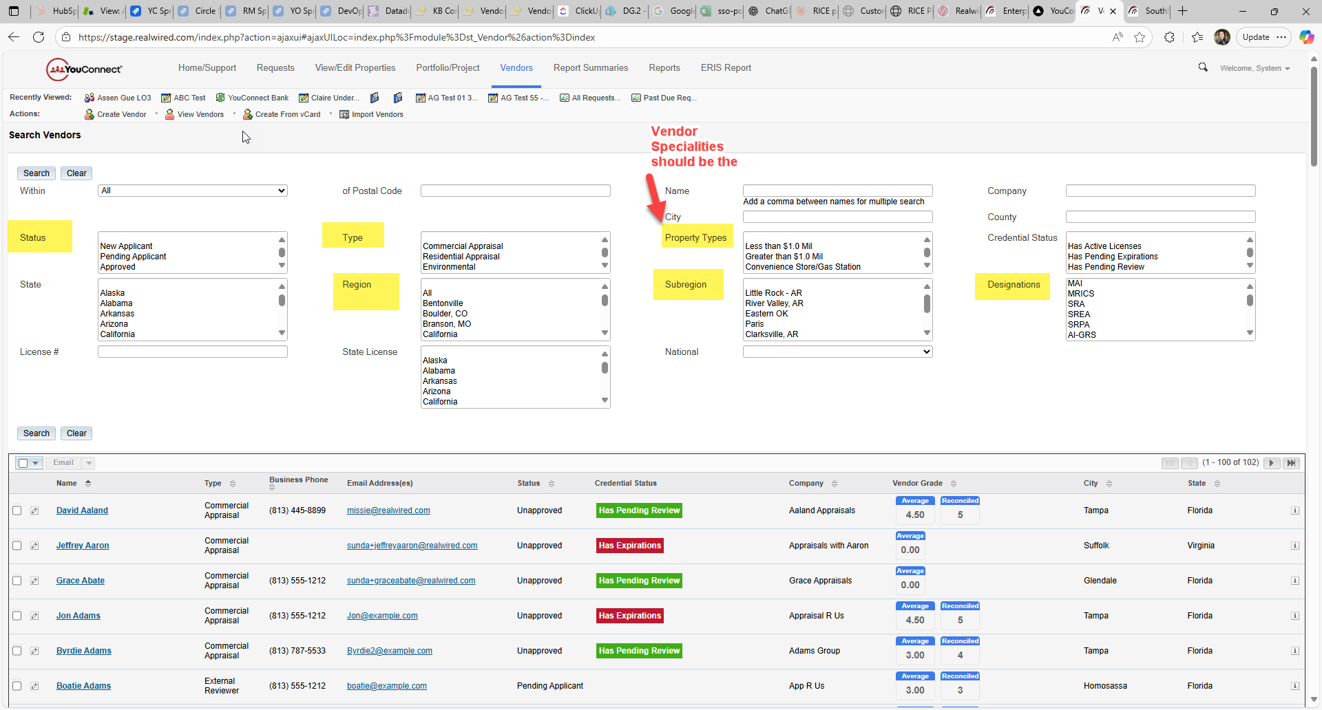
1st Configuration
Choose Vendor Types (They can relabel, remove or add these values)
Appraisal
Environmenta
Broker
External Evaluator
External Reviewer
Internal Evaluator
Internal Reviewer
2nd Configuration
Select what credentials you want monitored for each Vendor Type
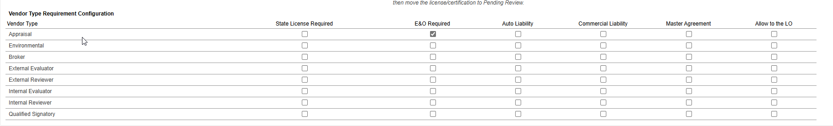

3rd Configuration
Add/Relabel Vendor Status (These are the default Statuses, they can add more)
New Applicant (Cannot be changed)
Pending Applicant (Cannot be changed)
Approved (Show that this is monitored)
Unapproved
Pending (Show that this is monitored)
Temporary Approval (Show that this is monitored)
Rejected
Retired
Deceased
NOTE: Additional Statuses can be added and set to be monitored but will NOT display when you solicit vendors. Only Approved, Temporary Approval and Pending statuses will display when vendors are solicited.
If a new status is entered, they should be able to select Monitor Credentials Y/N.
4th Configuration
Choose Vendor Specialties (They can relabel, remove or add these values)
Hotel
Convenience Store
Oil & Gas
Airport
Golf Course

5th Configuration
Choose Vendor Designation (They can relabel, remove or add these values)
MAI
MRICS
SRA
SREA
SRPA
AI-GRS
AI-RRS
Certified Residential
Certified General
Trainee
6th Configuration
Choose Vendor Regions (They can relabel this field and choose any values desired to assist in searching for a vendor)
7th Configuration
Choose Vendor Sub Regions (this is NOT a related field, They can relabel this field and choose any values desired to assist in searching for a vendor)

